

**A Peek Inside**

I hope you enjoyed the season of goblins, ghosts and ghouls and got more treats than tricks!

Since our last month's edition, we have

had the opportunity to visit our alma

mater SYRACUSE UNIVERSITY for

a wonderful homecoming weekend.

This marks my 23rd college reunion

and provided an opportunity to

reconnect with friends I have not seen

in quite some time. Further, we had

the opportunity to take our first college

tour with Rachel. It was very

entertaining yet emotional for both

Amy and I for any number of reasons.

After our homecoming weekend

experience, we continued our journey and went with friends to Niagara Falls. We did the Maid of the Mist and experienced one of the eight wonders of the world. We stayed on the Canadian side and watched fireworks over the falls Sunday night. Also, the hotel where we stayed housed the largest water park in North America. Guess where we wound up Monday morning??? It was a great weekend which I give my wife all the credit for having arranged.

WE also had the opportunity to finish fall baseball which Ben enjoyed; not only because he had the opportunity to play the positions he wanted including pitcher but it was pretty cool as he puts it to have Dad as his coach. Anna continues to play goalie for her Pennington Puma team which continues for still a few more weeks. As the holidays approach, we have started planning our winter activities and I am exhausted already. Just Kidding. I certainly look forward to sharing this holiday season with everyone. I want to thank everyone for their continued commentary regarding the newsletter and ask that you continue to like us on Facebook or connect with us on twitter or LinkedIn. I am so very thankful for the wonderful people in my life and I wish all of you the very best Thanksgiving Holiday! See you in December!

Also, if you would like to have someone receive our newsletter please have them call 609-771-8611 or email me at [sgaylord@gaylordpopp.com](mailto:sgaylord@gaylordpopp.com).

Sam Gaylord

**November 2014 * Vol. 1 * No. 9**

**JUNE 2013**

**ARIAL 15 POINT BOLD CAPS FOR CO. NAME**

Hello! We are pleased to send you this monthly issue of *Strive For Excellence.*  It is our way of saying that you are important to us and we truly value your business. Please feel free to pass this newsletter on to friends and neighbors. Enjoy!

**Monthly Joke**

**Spelling Problem**

A woman and her husband were driving when their car’s brakes failed.

They hit a wall, and the husband was injured. The wife pulled out her cell phone to call 911.

“Help!” she cried. “We’ve had an accident and my husband needs an ambulance.”

“Where are you, ma’am?” the dispatcher asked.

“I’m on Eucolipstic Road just outside of town.”

“Can you spell that for me?”

The woman paused. “How about if I drag him over to Oak and you can pick him up there?”

**QUOTE OF THE MONTH**

*One of the advantages of being disorderly is that one is constantly making exciting discoveries.*

—A.A. Milne

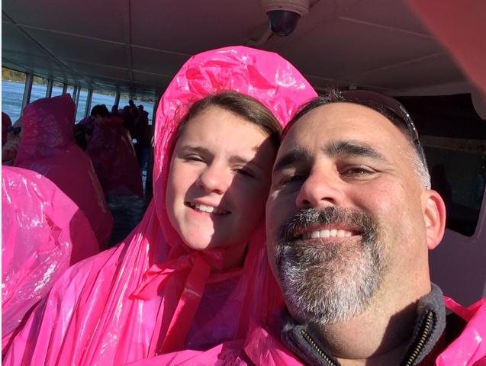



**MONTH YEAR**

**Learning Matters…**a

**The Best Vegetarian Chilli**

Original recipe makes 8 servings

1 tablespoon olive oil

1/2 medium onion, chopped

2 bay leaves

1 teaspoon ground cumin

2 tablespoons dried oregano

1 tablespoon salt

2 stalks celery, chopped

2 green bell peppers, chopped

2 jalapeno peppers, chopped

3 cloves garlic, chopped

2 (4 ounce) cans chopped green chile peppers, drained

2 (12 ounce) packages vegetarian burger crumbles

3 (28 ounce) cans whole peeled tomatoes, crushed

1/4 cup chili powder

1 tablespoon ground black pepper

1 (15 ounce) can kidney beans, drained

1 (15 ounce) can garbanzo beans, drained

1 (15 ounce) can black beans

1 (15 ounce) can whole kernel corn

1. 1. Heat the olive oil in a large pot over medium heat. Stir in the onion, and season with bay leaves, cumin, oregano, and salt. Cook and stir until onion is tender, then mix in the celery, green bell peppers, jalapeno peppers, garlic, and green chile peppers. When vegetables are heated through, mix in the vegetarian burger crumbles. Reduce heat to low, cover pot, and simmer 5 minutes.
2. 2. Mix the tomatoes into the pot. Season chili with chili powder and pepper. Stir in the kidney beans, garbanzo beans, and black beans. Bring to a boil, reduce heat to low, and simmer 45 minutes. Stir in the corn, and continue cooking 5 minutes before serving.*Source:* [*www.allrecipes.com*](http://www.allrecipes.com)

**Office News**

Recently, Rose Szabo, office manager and

paralegal extraordinaire, participated in her

first Color Run.  According to her “The happiest

5K on Earth! It is a run that is meant to celebrate

life, happiness, friendships, health and everything

that is happy!”  Participating with Rose was her

sister and other friends all dressed up in tutu’s

(b/c when else can a girl over the age of 30

wear a tutu and it be acceptable!  Those are

Rose’s words and not ours.) The name of the

team was “Pour Some Color on Me!” and as

you can see from the picture that is exactly

what they did.  Everyone had a great time at

the Englishtown Raceway and everyone is

looking forward to next year.

If you want to ask Rose about her participation

please feel free to e-mail her at [rszabo@gaylordpopp.com](mailto:rszabo@gaylordpopp.com).

*P.S. Do you know of any great events, like these, that are coming up? Email us to let us know so we can post it in the next issue!* [*sgaylord@gaylordpopp.com*](mailto:sgaylord@gaylordpopp.com)*.*

**The Responsibility Of The Host In Alcohol Related Injuries And Accidents**

In the news today there are more and more cases where someone that has been drinking either in a licensed bar, lounge or restaurant or even at someone’s private home gets into an accident and sues the person that was providing or serving the alcohol.

These are actually only two possible cases but they are the most common. Other issues include serving alcohol at a business or organization function or at an event such as a baseball game or a concert.

**Dram Shop Laws**

When a person is served in a licensed establishment it is the server’s responsibility to avoid continuing to serve alcohol to someone that is visibly intoxicated. That can include someone that arrives intoxicated or that becomes intoxicated in the bar.

Each state has their own dram shop laws but all states require that the bar monitor the patron’s intoxication and cut off service as necessary. If an intoxicated customer goes out and gets into an accident and hurts either themselves or someone else the bar can be held responsible in conjunction with the intoxicated person.

**Businesses, Groups and Special Events**

If you are having a business meeting, conference, special event or group or team activity and are serving alcohol you do need to limit your liability by monitoring alcohol consumption and ensuring that anyone that is visible intoxicated is prevented from drinking and from driving.

Businesses are generally seen as having a higher degree of liability in these cases, especially if attendance was mandatory at the event. The same is true for prof-essional organizations were it is a dual purpose meeting including educational or career related agendas combined with social events.

**CONT’D ON PG.3**

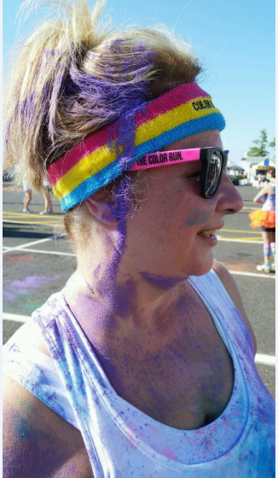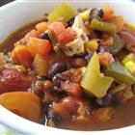

**Tech Tips with Dan Little**

Technology is risky and comes without instructions. For some

reason, there's no standard syllabus, there's no basic course.

They just sort of give you your computer and then kick you

out the door. You're supposed to learn this stuff how? Just by

osmosis. Nobody ever sits down and tells you, "This is how it

works." So today I'm going to tell you some things that you

thought everybody knew, but it turns out they don't.

On the web, when the text is too small, all you do is hold down the Control key and hit plus, plus, plus. You make the text larger with each tap. It works on every computer, every web browser, or minus, minus, minus to get smaller again.

When you're typing on your Blackberry, Android, iPhone, don't bother switching layouts to the punctuation layout to hit the period and then a space and then try to capitalize the next letter. Just hit the space bar twice. The phone puts the period, the space, and the capital for you. Go space, space. It is totally amazing.

Also when it comes to cell phones, on all phones, if you want to redial somebody that you've dialed before, all you have to do is hit the call button, and it puts the last phone number into the box for you, and at that point you can hit call again to actually dial it. So you don't need to go into the recent calls list, so if you're trying to get through to somebody, just hit the call button again.

Okay, so most of us think of Google as something that lets you look up a webpage, but it is also a dictionary. Type the word "define" and then the word you want to know. You don't even have to click anything. There's the definition as you type.

Google is also a complete FAA database. Type the name of the airline and the flight. It shows you where the flight is, the gate, the terminal, how long till it lands. You don't need an app for that.

And finally, it often happens that you're giving a talk, and for some reason the audience is looking at the slide instead of at you. So when that happens, this works in Keynote, PowerPoint, it works in every program, all you do is hit the letter B key, B for blackout, to black out the slide and make everybody look at you, and then when you're ready to go on, you hit B again, and if you're really on a roll, you can hit the W key for whiteout, and you white out the slide, and then you can hit W again to unblank it.

**About Dan Little:** *Dan is the Head Honcho at A Different Kind of IT, an Information Technology and Services Consulting Firm with a Difference based in Philadelphia. Interested in hearing more? Email* [*info@different-kind-it.com*](mailto:info@different-kind-it.com)

**IN THE COMMUNITY……**

Clara Sampson over 30 years ago founded the women workers

of Jerusalem Baptist Church in Trenton, New Jersey and today

is its coordinator. The small group of members started out by

giving a dinner to the needy of Trenton four times a year and

distributed baskets of food to a handful of families for

Thanksgiving.

Currently, this wonderful organization feeds approximately 300 people monthly, gives away clothing, bread and other personal items. On November 15th there will be a dinner from 11 am to 1 pm which I will be participating in and on November 24th a Turkey Give Away at 5 pm. In addition, The Willing Workers are looking for coat donations for this year’s winter coat drive. If you are interested in learning more about this great group you can contact Ms. Sampson at 609-631-0355 or 609-222-2770 or you can visit them at 150 N. Clinton Ave. Trenton, New Jersey 08609 or visit their site at [www.jerusalemmbc-nj.org/](http://www.jerusalemmbc-nj.org/)

**Alcohol Related Injuries Cont’d…**

**Private Events**

An individual hosting a party at his or her own home or residence may also be liable for injuries to others that are caused by a person leaving the party intoxicated. Usually if the intoxicated person hurts only themselves or property the host is not considered liable unless they encouraged drinking, continued to serve a highly intoxicated person or if the individual was a minor and was provided alcohol at the house party or event.

**THANKS TO OUR CLIENTS!**

Our practice continues to grow and we recognize that our best clients come from your referrals.  Referrals are welcome and we want to take a moment and THANK those who have referred new clients to US.  It’s the biggest compliment we can receive!

**Many thanks to:**

**Greg Addeye**

**Sheila Addeye**

**Susan Johnson**

**Constance Weiss**

**Ellen Brown**

**Lawrence Allen**

**Amy Serrano**

**Yassah Mehn**

**Trancy Smith**

**Brian Berrian**

**Be sure to visit our website at** [**www.gaylordpopp.com**](http://www.gaylordpopp.com)

**for free offers**

**and connect with us via:**

**Financially Speaking…**

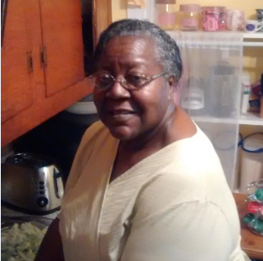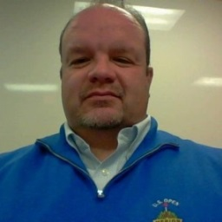

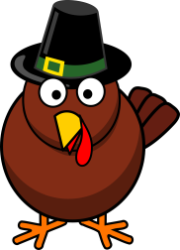

**Chiropractic Tips**

Everyone has to go through   
the trials of everyday life and   
even daily chores can result   
in a lot of people sustaining   
injuries. To make sure that   
you do not injure your spine   
there are a few tips you   
should follow that can help   
you to stay in good shape.

One good tip is to sit rather slouch. Pick a chair which can comfortably but firmly support you against the rear of the chair and sit with your feet flat on the floor or even on a small footstool that allows your knees to be slightly above your hips.   
  
Avoid having your legs crossed as this can aggravate pre-existing back conditions and block circulation to lower limbs.

When you stand up, make sure that you do so with your head level. If you are likely to be standing for lengthy periods of time avoid wearing high heels and if possible place one foot onto a stool about four to six inches in height to take pressure off of your spine.

**What are you thankful for this year?**

**Be grateful for all the wonderful**

**people in your life and enjoy your**

**Thanksgiving this month!**

***Sam Gaylord***

**IN THIS ISSUE YOU WILL FIND:**

* **A Peek Inside**
* **The Responsibility Of The Host In Alcohol Related Injuries And Accidents**
* **The Best Vegetarian Chilli Recipe**
* **Office News**
* **Tech Tips With Dan Little**

**…and more!**

Samuel Gaylord specializes in the areas of Workers’

Compensation, Social Security Disability and Disability Pension Appeals. Mr. Gaylord is certified by the New Jersey Supreme Court as a workers compensation law attorney and is admitted to practice in New Jersey, Pennsylvania and Washington D.C and before the United States Supreme Court.

**COPYRIGHT 2014 CUSTOM NEWSLETTERS, INC NEWSLETTER DESIGNED BY THE NEWSLETTER GURU ALL RIGHTS RESERVED, WWW.NOHASSLENEWSLETTERS.COM**

**A MONTHLY NEWSLETTER TO INFORM AND ENTERTAIN OUR CUSTOMERS** **November 2014 * Vol. 1 *No. 9**

**Happy Thanksgiving!**

* Benjamin Franklin wanted not the bald eagle, but the Turkey to be the national bird!
* Abraham Lincoln issued a 'Thanksgiving Proclamation' on third October 1863 and officially set aside

the last Thursday of November as the national day for Thanksgiving.

* In the US, approximately 280 million turkeys are sold for the Thanksgiving celebrations.
* In Canada, it’s celebrated on the 2nd Tuesday in October.
* Turkeys will have 3,500 feathers at maturity. That’s a lot of feathers to pluck!
* 91% of American’s eat Turkey on Thanksgiving.

**GaylordPopp Attorneys**

Mountain View Office Park

850 Bear Tavern Road; Suite 308

Trenton, NJ 08628

609-246-0667 www.gaylordpopp.com